**1. man command->**

**Syntax : man [command]**

**Example: man ls**

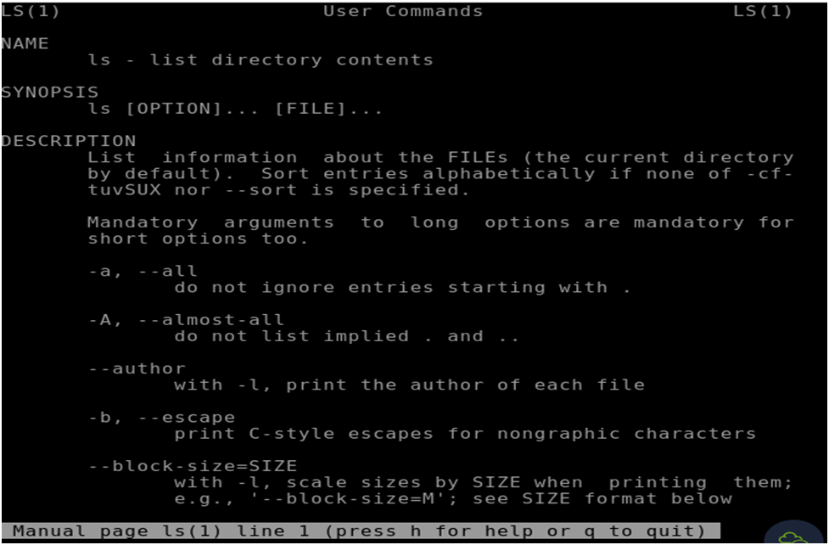

**2. whatis command ->**

**Syntax: whatis [command]**

**Example:  whatis pwd**



**3.    date command ->**

**Syntax: date [option]...[+format] date [-u|--utc|--universal] [MMDDhhmm[[CC]YY][.ss]]**

**Example:  date -u**





**4. ps command ->**

**Syntax: ps[options]**

**Example:  ps**

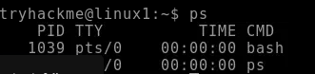

**5.  mkdir command ->**

**Syntax: mkdir [directory]**

**Example:  mkdir GeeksForGeeks**

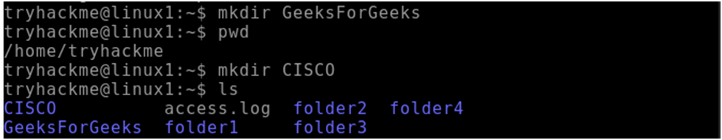

**6.   touch command ->**

**Syntax: mkdir [directory]**

**Example:  mkdir GeeksForGeeks**



**7.   rmdir command ->**

**Syntax: rmdir [OPTION]... DIRECTORY...**

**Example:  rmdir newdocuments**



**8.  mov command ->**

**Syntax: mv [options(s)] [source_file_name(s)] [Destination_file_name]**

**Example:  mov country.txt State.txt**



**9.   cd command ->**

**Syntax: cd [directory]**

**Example:  cd country.txt**



**10.   pwd command ->**

**Syntax: pwd [options]**

**Example:  pwd -L**



**11.   cat command ->**

**Syntax: cat [OPTION]... [FILE]...**

**Example:  cat capital.txt**

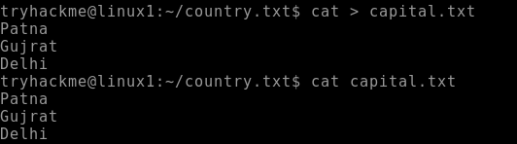

**12.   cat > command ->**

**Syntax: cat >[OPTION]... [FILE]...**

**Example:  cat > capital.txt**



**13.   cat >> command ->**

**Syntax: cat>> [OPTION]... [FILE]...**

**Example:  cat >> t.txt**

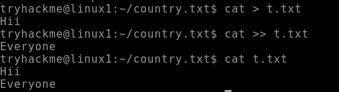

**14.  cp command ->**

**Syntax: cp [OPTION]... SOURCE... DIRECTORY**

**Example:  cp text.txt t.txt**

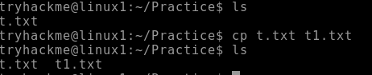

**15.  chmod command ->**

**Syntax: chmod [options] [mode] [File_name]**

**Example:  chmod u+x t.txt**

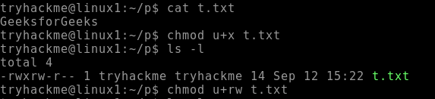

**16.   cal command ->**

**Syntax: cal [ [ month ] year]**

**Example:  cal 04 2024**

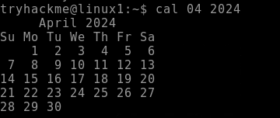

**17.  ifconfig command ->**

**Syntax: ifconfig [interface] [options]**

**Example:  ifconfig**

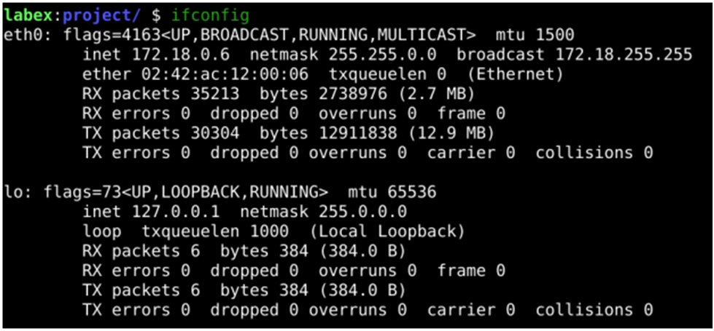

**18.   echo command ->**

**Syntax:echo [option] [string]**

**Example:  echo “Hello World!”**

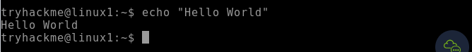

**19.   grep command ->**

**Syntax: grep [OPTION]... PATTERNS [FILE]...**

**Example:  grep -l “unix” \***

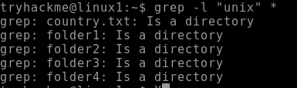

**20.   ls -l command ->**

**Syntax: ls -l[OPTION]... [FILE]...**

**Example:  ls -l country.txt**

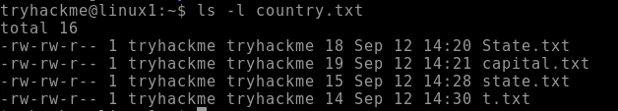

**21.   ls -a command ->**

**Syntax: : ls -a [OPTION]... [FILE]...**

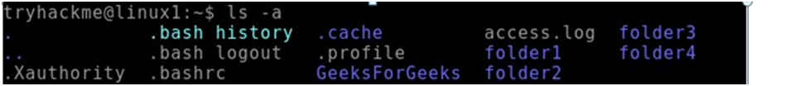

**22.   ls command ->**

**Syntax: ls [OPTION]... [FILE]...**

**Example:  ls -l**

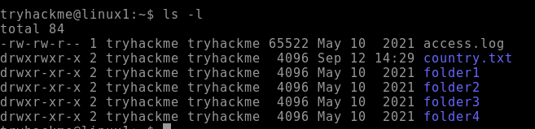

**23.  whoami command ->**

**Syntax: : whoami [OPTION]...**

**Example:  whoami**

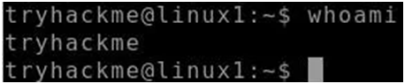

**24.   find command ->**

**Syntax: find [path] [options] [expression]**

**Example:  find –type f –name note.txt**



**25.  less command ->**

**Syntax: less[OPTION][FILENAME]**

**Example:  less –N t.txt**



**26.   more command ->**

**Syntax: more [options] <file>...**

**Example:  more –f t2.txt**

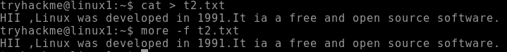

**27.   join command ->**

**Syntax: join [OPTION]... FILE1 FILE2**

**Example: join t2.txt t3.txt**



**28.   paste command ->**

**Syntax: paste [OPTION]... [FILE]...**

**Example:  paste t2.txt t3.txt**

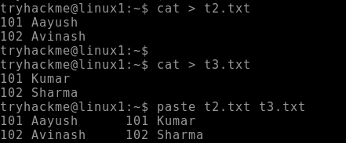

**29.   ln command ->**

**Syntax: ln [OPTION]... [-T] TARGET LINK_NAME (1st form)**

**ln [OPTION]... TARGET... DIRECTORY (2nd form)**

**ln [OPTION]... -t DIRECTORY TARGET... (3rd form)**

**Example:  ln program.py link.py**

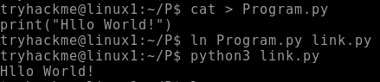

**30.  head command ->**

**Syntax: head [OPTION]... [FILE]...**

**Example:  head –n 3 State.txt**

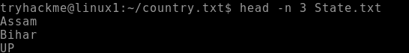

**31.   tail command ->**

**Syntax: tail [OPTION]... [FILE]...**

**Example: tail –n 2 capital.txt**

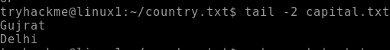

**32.   wc command ->**

**Syntax: wc [OPTION]... [FILE]...**

**Example:  wc State.txt**

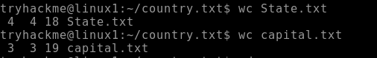

**33.  wc -l command ->**

**Syntax: wc [OPTION]... [FILE]...**

**Example:  wc –l State.txt**



**34.  kill command ->**

**Syntax: kill [signal] PID**

**Example:  kill -9 1184**

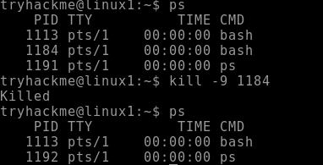

**35.   killall command ->**

**Syntax: killall [signal] PID**

**Example:  killall -l**



**36. rev command->**

**Syntax:rev [option][File…]**

**Example: rev t.txt**

**rev -V**

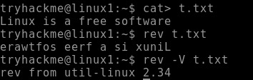

**38. cmp command->**

**Syntax:cmp[OPTION]....FILE1 [FILE2 [SKIP1 [SKIP2]]]**

**Example: cmp t.txt t2.txt**

**cmp -b t.txt t2.txt**

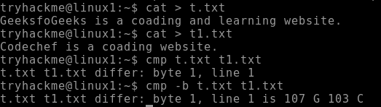

**37. rm command->**

**Syntax:rm[OPTION..][FILE….]**

**Example: rm t.txt**

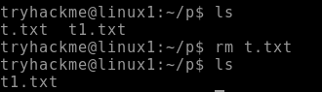

**39. function command->**

**Syntax: function name { COMMANDS ;}**

**Example: function hello**

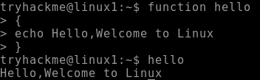

**40. sort command->**

**Syntax: sort [OPTION]... [FILE]...**

**Example: sort sortdemo.txt**

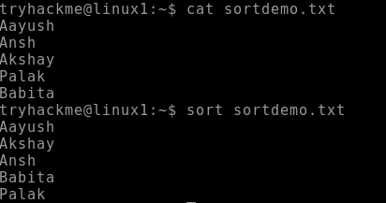

**41. split command->**

**Syntax: split [OPTION]... [FILE [PREFIX]]**

**Example: split -l 2 course.tx**

